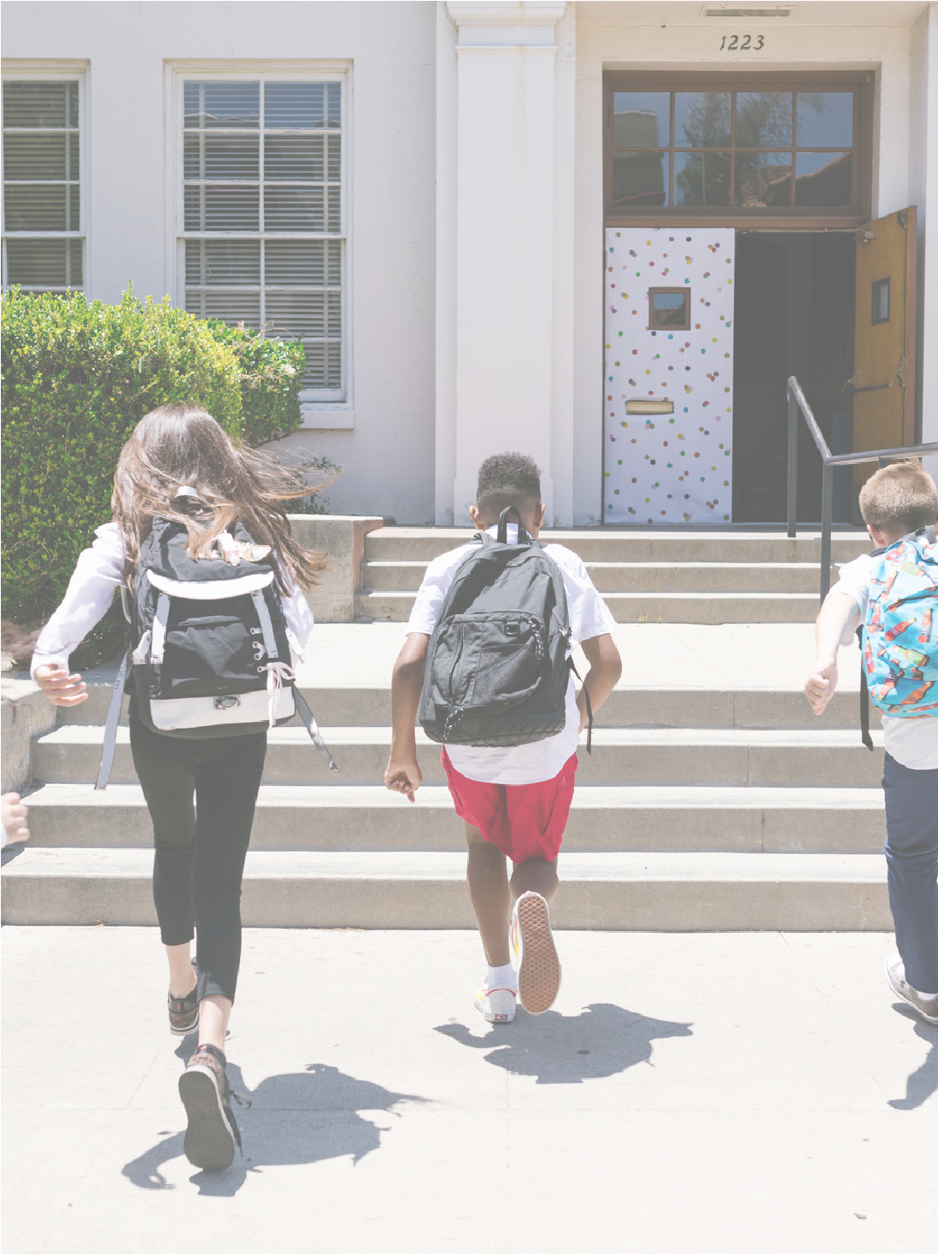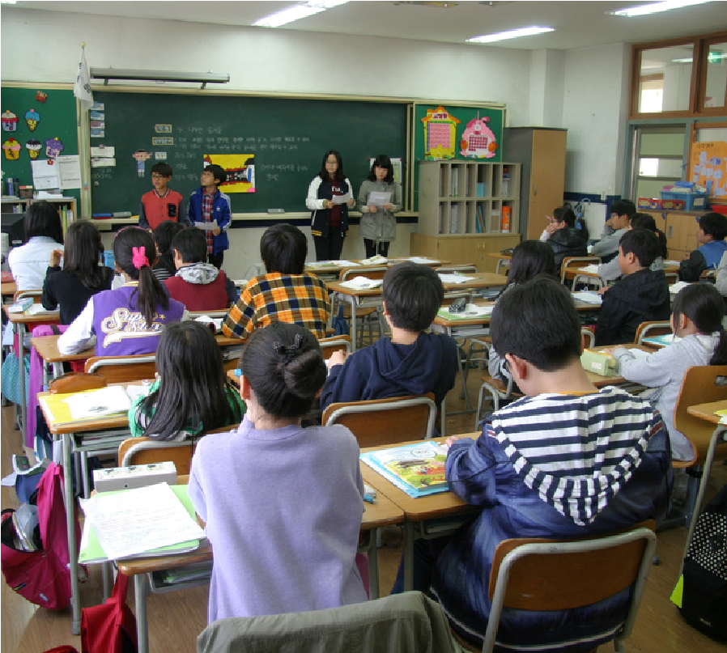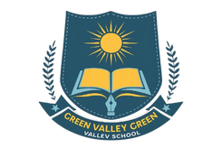

**Admission**

**Open**

**Now**

**Welcome to**

**Green Valley School**

We ensure that every child

receives:

Personal attention

A positive learning

environment

Opportunities to explore

talents

Guidance to grow

academically and socially

GREEN

VALLEY

SCHOOL

Where learning meets growth

classes :

**PG to O levels**

At Green Valley School, we nurture the

minds

and

hearts

of

students

through

quality

education,

character

building,

and a safe learning environment.

We aim to develop confident, creative,

and responsible individuals ready for the

future.

**Contact Us**

+123-456-7890

hello@reallygreatsite.com

www.reallygreatsite.com

123

Anywhere St., Any City,

ST 12345